3 September 2009

Mr Frank Thompson and Mrs Ilse Thompson
78 Brady Road
Gisborne VIC 3437

Dear Frank and Ilse,

I am pleased to enclose your Statement of Advice (SoA).

It is an important document that you should read and understand before making a decision to proceed further.

We have based the strategies and recommendations in this document on our understanding of your current personal and financial position. If any of this information does not reflect any part of your current position, goals and objectives please advise us immediately and we will make the necessary changes.

The SoA sets out our recommended strategies to address your needs, together with a recommended course of action to implement these strategies.

When you are ready to proceed, we would be very happy to help you with the implementation of the advice, including the completion and lodgement of application forms and other documents.

Please note, our recommendations in this Statement of Advice are valid for 30 days from the date on the cover of this document. If your circumstances change before you implement our recommendations, or if you don’t act on them within 30 days, they may no longer be appropriate for you. If that happens, please ask us to review your situation again before you take any action.

Once implemented, we should review your situation on a regular basis to ensure we make the most of any changes that may impact on the strategies I have recommended for you.

Yours sincerely,

Andrew Lord

B Bus (Acc), Dip FS (Fin Plan)
Authorised Representative No.324798 of
Guardianfp Ltd trading as Guardian Financial Planning




Frank Thompson and Mrs Ilse Thompson
of

78 Brady Road
Gisborne VIC 3437

Telephone: 5428 3978
Email: fcthompson@mgs.vic.edu.au

Prepared by

Andrew Lord B Bus (Acc), Dip FS (Fin Plan)

Level 9, 606 St Kilda Road
Melbourne VIC 3004

Telephone: (03) 9510 0788

Fax: (03) 9510 0799

Email: andrewl@lakesideconsultants.com.au

Authorised Representative

of

Guardianfp Ltd trading as Guardian Financial Planning
ABN 40 003 677 334 Australian Financial Services Licensee No. 237641
Level 10, 321 Kent Street, Sydney, NSW, 2000
Phone: 1300 720 350 Fax: 02 8275 3232 E-mail: enquiries@guardianfp.com.au

3rd September 2009 

What this document is about
This Statement of Advice (or SoA) is an important document.
- It provides you with information about our advice so you can make a decision about implementing the advice.
- It should be read in conjunction with other documents such as Product Disclosure Statements and our Financial Services Guide.

What to do after reading this Statement of Advice
Please contact us.
- If you have any questions.
- If we have omitted, overlooked or incorrectly understood any of your relevant circumstances.
- When you are ready to implement the recommendations.
- Or, if you decide you want to do something else and need our advice or assistance.

Table of Contents
Purpose of this document 5
Timeframe for our advice 5
Check for accuracy 5
Limitations of our advice 5
Thank you for choosing Guardian Financial Planning 6
Product selection 6
Introduction 7
The Scope of Our Advice 7
Our Investment Recommendations 7
Your Adviser 8
The Planning Process 8
Executive Summary 9
Your Goals and Objectives 9
Recommendation Overview 9
Anticipated Outcomes 9
Future Strategies 10
Personal Information 11
Personal Details 11
Health Details 11
Employment Details 11
Dependants 11
Estate Planning 11
Assets and Liabilities 12
Current Risk Management Policies 13
Income and Expenses 13
Your needs, goals and objectives 14
Your Investor Risk Profile 15
Strategy Recommendation 17
Planned Expenditure 17
Retirement Planning 17
Superannuation Funds 18
Protected Super 19
Salary Sacrifice to Superannuation 21
Superannuation - Retirement Income Streams 22
Reversionary Pensions 23
Superannuation Contribution Limits 24
Estate Planning 25
Powers of Attorney 25
Investment Recommendations 27
Current Portfolio 27
Proposed Portfolio 28
Projected Portfolio Profile Compared to Benchmark 30
Replacement of an Existing Product 33
Cash Flow Projections Post Recommendation 34
What is paid to your adviser 35
Plan Fee 35
Internal Investment Fees 35

Upfront and Ongoing Fee Disclosure 37
Disclosure Statement 38
Summary 41
Appendix – Assumptions 43
Authority to Proceed 48

Purpose of this document

The following Statement of Advice (SoA) is an outline of the financial plan discussed with your financial planner. It details the recommendations needed to execute your plan and achieve your financial objectives.

Timeframe for our advice

Our recommendations in this SoA are valid for 30 days from the preparation date on the cover of this document. If your circumstances change before you implement our recommendations, or if you don’t act on them within 30 days, they may no longer be appropriate for you. If that happens, please ask us to review your situation before taking any action.

Check for accuracy

This SoA is based on the information you provided. Please read the document carefully, checking that your details are correct and that no important facts are missing. If anything is wrong or missing, please let us know immediately—otherwise our advice may be based on incorrect information and may not be right for you.

Limitations of our advice

We cannot give advice on:
- Trust or business structures | - Direct share or property purchases
- Taxation | - Legal matters
- General insurance

Please don’t consider any of this document’s recommendations to be advice in any of these areas. If you need advice in these areas, please see a qualified professional in that field.
Assumptions we've made

When giving advice, we make certain assumptions to demonstrate how the advice could affect your financial situation. We've based our advice on economic information and legislation that was current when we prepared your SoA.

All dollar amounts in this SoA are in today’s dollars, even when we mention future income, expenses, investment amounts and so on. Naturally we can’t predict what future inflation rates will be, so we can only make assumptions based on past trends. Also, all amounts listed in this document are “p.a.” (per annum) unless otherwise stated or implied.

We've also made assumptions about rates of return on the different types of investments which you may currently hold. So unless you have told us what return you are getting from your existing investments, we'll assume the following rates:
Investment Type | Assumed rate of return  Income | Assumed rate of return  Growth | Assumed rate of return  Income | Assumed rate of return  Growth
Cash | 5.80% | 0.00% | Australian Shares | 4.50%
Australian Fixed Interest | 5.00% | 0.00% | International Fixed Interest | 4.00%
Direct Property | 6.60% | 2.90% | International Shares | 2.60%
Listed Property Trusts | 4.90% | 1.60% | Alternatives | 3.80%

Thank you for choosing Guardian Financial Planning
Guardian Financial Planning is owned by Asteron Limited ABN 94 000 015 949 and is part of the Asteron group of companies which comprises: Asteron Portfolio Services Limited, Asteron Life Limited, Tyndall Investment Management Limited, Tyndall Asset Management Limited, Asteron Advisory Services Limited, Standard Pacific Consulting Limited and Standard Pacific Accounting Ltd. The Asteron Group of companies is ultimately owned by Suncorp-Metway Limited ABN 66 010 831 722 (“Suncorp”). Suncorp is listed on the Australian Stock Exchange. The different entities of the Suncorp Group are not responsible for or liable in respect of products or services provided by other entities of the Suncorp Group.

Some of the products and services we may deal in and advise on your behalf are provided by other Suncorp companies. These companies are listed in the section headed ‘Who owns Guardian Financial Planning’ in the copy of the Financial Services Guide we gave you. This document also outlines who your Authorised Representative is and their contact details in the section headed ‘Before you get advice – Who is my adviser?’ Please ask if you’d like another copy free of charge.

Product selection

We are committed to giving you the best products for your situation. When preparing your advice we considered and recommended only those products on Guardian Financial Planning’s “Approved Product List”. This list was compiled by a dedicated Investment Review Committee, which regularly reviews it. To see the complete product list, please ask us.

Introduction

You are entitled to receive a Statement of Advice (SoA) whenever we provide you with any personal financial advice. Personal financial advice is advice that takes into account any one or more of your objectives, financial situation and needs.

This SoA is a record of the personal financial advice provided to you and includes information on the basis on which this advice is given, information about remuneration including fees, commissions, any other benefits and any interests, relationships or associations which might influence the making of the advice.

If this advice includes a recommendation to you to acquire a particular financial product (other than securities) or an offer to issue or arrange the issue of a financial product to you, we will also provide you with a Product Disclosure Statement containing information about the particular product to help you make an informed decision about that product.

The Scope of Our Advice

Your instructions to us have not placed any limitations on the extent of our advice. You wish for us to review your entire financial position.

In this statement of advice, the main focus is on:
- Retirement Planning
- Superannuation.

This advice is based on information we have obtained from you. You must ensure the information is accurate and complete. Otherwise, this advice may be based on inaccurate or incomplete information relating to your investment objectives, financial situation or needs. You must therefore assess whether the advice is appropriate, in the light of your own individual investment objectives, financial situation or needs.

You recognise in each of the areas of advice we provide, we only provide advice to the extent we are able to under the relevant legislation.

Our Investment Recommendations

In respect of the specific investments we recommend as part of our advice you are entitled to a 14 day cooling off period for your initial investment. A cooling off period generally means a period of time after which you have provided your capital for investment, where you can change your mind and request for your capital to be returned to you.

Each fund manager or investment provider may implement the cooling off period in a slightly different manner. Therefore we recommend you refer to the Product Disclosure Statement for each of the recommended investments in order to understand the operation of each provider’s cooling off period.

Your Adviser

At any time should you have any questions or concerns, in the first instance please contact your adviser Andrew Lord on (03) 9510 0788.

Andrew Lord is authorised to represent Guardianfp Limited. Should you wish to discuss matters of concern about your adviser or the advice you have received please contact our Compliance Officer on 1800 687 620.

The Planning Process

Frank and Ilse, Financial Planning is a process to help you reach both your Personal and Financial Goals and Objectives. In order to achieve this we jointly need to undertake a number of tasks, including:

- Confirm your personal goals and lifestyle objectives;
- Quantify the resources required to meet your goals and objectives;
- Identify any gaps in your current plans and your stated goals and objectives;
- Develop suitable strategies to address any differences that may exist bearing in mind your attitude to investing and your risk profile;
- Conduct a regular review of the strategies we put into effect to ensure they keep pace with your changing needs, legislative changes and the investment environment.

Executive Summary

In this plan our advice considers the following areas of your financial circumstances.

Your Goals and Objectives

After our discussions I have listed below what we agreed were your key goals and objectives. The points listed below form the basis of the plan I have prepared, and therefore you should read them carefully now to ensure that we have an accurate foundation on which to proceed. If there are any modifications required, please advise us prior to the commencement of your financial plan.

Your goals and objectives are to:
- Take advantage of current superannuation legislation especially tax free income from age 60, and therefore seek advice on ways to transition moneys from outside superannuation into the super environment.
- Review your superannuation contribution strategies with the aim of increasing your retirement savings in a tax effective manner.
- Review your superannuation portfolio.
- Invest in a tax effective investment portfolio that has a focus on growth over the long term, whilst retaining a reasonable level of capital security.
- Minimise your tax commitments.

Recommendation Overview
Considering your stated goals and objectives, investor risk profile and age we recommend that you:
- Ilse, transfer $150,000 of your defined benefit fund to AXA North Growth Guarantee Pension, $160,000 to Colonial First State Wholesale Pension and have the remainder in cash at bank for your kitchen renovations.
- Invest your funds in a diverse mix of funds that are in line with your investor risk profile.
- Frank, salary sacrifice $45,000 per annum ($3,750 per month) to your existing employer fund.
- Ilse, draw down $22,000 as a pension across both your AXA and Colonial First State super funds for living expenses.

Anticipated Outcomes
Following our recommendations, we anticipate that:
- Your surplus cash flow will have reduced by $605 to $508 per annum.
- Your income tax liability will be reduced by $10,395.
- Your capital is invested inside and outside of the superannuation environment consistent with your investor risk profile.
- Your combined superannuation balance will increase by an additional $6,050 per annum.
- You have increased your superannuation contributions to build a capital base to meet your retirement income goals.
- You have re-structured your superannuation assets and increased the tax effectiveness of your retirement benefits upon commencement of an income stream.

Future Strategies

- To annually review superannuation contributions, investment performance and cash flow requirements. We will aim to meet in March/April each year to review.
- Closer to Frank’s retirement we will provide you with recommendations and advice relating to the retirement stage of your financial plan.

Personal Information

During our discussions and from the information you have provided, your Personal Details can be summarised as follows:

Personal Details
 | Frank | Ilse
Title | Mr | Mrs
First Name | Frank | Ilse
Surname | Thompson | Thompson
Gender | M | F
Date of Birth | 27/10/1949 | 01/08/1949
Age Last Birthday | 59 | 60
Marital Status | Married | Married

Health Details
Health Status | Good | Good
Smoking Status | No | No

Employment Details
Employment Status | Employee – Full Time | Retired
Occupation | Teacher | -
Employer | Melbourne Grammar School | -
Proposed Retirement Age | 63 | 60

Dependants
Name |  | Date of Birth | Dependency To Age
No Dependant Children

Estate Planning
 |  | Frank |  | Ilse
Do you have a Current Will? |  | Yes |  | Yes
Date Last Reviewed |  | 2007 |  | 2007
Do you have Current Powers of Attorney? |  | No |  | No
Do you have a Testamentary Trust? |  | Yes |  | Yes

Assets and Liabilities

The following is an Asset and Liabilities summary that estimates your Net Worth position based on the information provided.

ASSETS
Lifestyle Assets | Value
Frank and Ilse
Residential Home | $550,000
Motor Vehicles | $40,000
Total Lifestyle Assets | $590,000

Investment Assets
Frank and Ilse
Shares (QBE) | $20,000
Cash at Bank | $80,000
Total Investment Assets | $100,000

Superannuation Assets
Frank
Mercer Super Trust | $310,000
Ilse
ESSSuper | $340,000
Total Superannuation Assets | $650,000

Total ASSETS | $1,340,000

LIABILITIES
Personal Loans
Frank and Ilse
Residential Home | $40,000
Total Personal Loans | $40,000

Investment Loans
Frank and Ilse
Shares | $100,000
Total Investment Loans | $100,000

Total LIABILITIES | $140,000

NET WORTH | $1,200,000

Notes: As the above information has been used in preparing our recommendations please advise us of any errors or omissions.

The ‘Total’ column indicates the value of assets and liabilities which are owned by the client and/or partner. This report does not show the value of any portion of the asset or liability that may be owned by a third party or associated entity.

Current Risk Management Policies

Frank and Ilse presently have no personal insurances.

Income and Expenses

The following is a summary of your Income and Expenses that estimates your overall Cash Flow position based on the information provided.

Current Estimated Tax Liability for Frank

Income Source |  | Amount Received | Deduction | Taxable Income | Tax
Gross Salary |  | $95,221
Deductions
Employer Super Contributions |  |  | $4,761
Other |  |  | $840
Salary Sacrifice |  |  | $12,000
Motor Vehicle Salary Sacrifice |  |  | $6,141
TAXABLE INCOME |  |  |  | $71,479
TAX PAYABLE |  |  |  |  | $15,294
Medicare Levy |  |  |  |  | $1,072
NET TAX |  |  |  |  | $16,366

Current Estimated Cash Flow

Based on your stated income, expenses and current tax position we estimate your cash flow over one whole financial year to be as follows.

 | Frank | Ilse | Total
Income
Salary | $95,221 | $0 | $95,221
Sub Total | $95,221 | $0 | $95,221
Less Income Tax | $16,366 | $0 | $16,366
Less salary sacrifice | $12,000 | $0 | $12,000
Less other pre-tax deductions | $11,742 | $0 | $11,742
Net Income | $55,113 | $0 | $55,113
Less Budgeted Expenditure | $27,000 | $27,000 | $54,000
Income Surplus | $28,113 | ($27,000) | $1,113

Your needs, goals and objectives

From our discussions and your Fact Find, we identified these as your needs, goals and objectives:

Frank and Ilse,

- You wish to reduce the amount of tax payable wherever possible.
- You need to allow for the following capital expenditures:

Your expected capital expenditures
Owner | Description | Amount ($) | When
Frank and Ilse | Kitchen Renovation | $30,000 | Now
Frank and Ilse | Bathroom Renovation/Travel | $30,000 | 2010

- You wish to maximise the return on your investments in line with the level of risk you are comfortable to take.

Your Investor Risk Profile

The following section of your plan helps to ensure that I clearly understand your attitude to investment selection. Additionally, investments contain various characteristics, which may or may not suit each individual investor.

Based upon your responses to the Risk Profile Questionnaire, it was determined you have a Growth investor risk profile.

We discussed the impact of the investment term and how this would impact your investor risk profile in regards to both superannuation and non-superannuation assets.

Based upon our discussions and your attitude towards investments, financial markets and risk, we mutually agreed you best fit the characteristics of a ‘Growth’ to ‘Balanced’ investor for all superannuation investments.

Typically, a Growth investor has the following characteristics:

- A Growth investor places greater emphasis on capital appreciation with current income and asset preservation being of a secondary concern.
- This requires an investments time horizon of between 5 – 7 years.
- Their portfolio would typically comprise an overweight holding in shares and property with a small exposure to income bearing securities such as cash and fixed interest.

A Growth investor will typically diversify their investment in the following manner:

Australian Shares 45%
International Shares 31%
Fixed Interest 12%
Property 10%
Cash 2%

Typically, a Balanced investor has the following characteristics:

- The Balanced investor will typically operate a portfolio evenly split between interest bearing securities and growth oriented investments.
- An exposure to a range of investment sectors including cash, fixed interest, property and shares ensures the portfolio is “truly” balanced.
- Investors are typically comfortable with a variability of their capital over a 5 year horizon while their portfolio builds a growing income stream and capital growth.

A Balanced investor will typically diversify their investment in the following manner:

Australian Shares 35%
International Shares 25%
Fixed Interest 25%
Property 10%
Cash 5%

Our research indicates that long term returns will be best achieved through a diversified portfolio covering all major asset classes (i.e. Cash, Fixed Interest, Shares and Property).

By covering all primary investment markets the risks and volatility of your investments can be managed to levels consistent with your investment profile, whilst maintaining the potential for long term growth.

If you feel the above investor profiles do not reflect your attitude as an investor, or the recommended portfolio contained in this report is too aggressive or conservative, please let me know so I may adjust my recommendations accordingly.

Our recommendation has been made given your risk tolerance, while in balance with your goals and objectives.

Note: For more information please refer to the appendices titled – ‘Investment Returns and Risks’ and ‘How Diversifying Reduces Risk’.

Strategy Recommendation

Planned Expenditure

Recommendations:

- To fund your estimated renovation and travel cost of $60,000 we recommend to:
  - Hold $30,000 of the $340,000 from Ilse’s defined benefit in cash outside of superannuation for ease of access for the kitchen renovation.
  - The additional $30,000 may be drawn in one or more lump sums from super when required.

Retirement Planning
Ilse, you are currently retired. Frank, based on our discussions your indicative retirement age is 63. We have calculated your required retirement income based on your current living expenses of $54,000 pa.

- To achieve a retirement income of $54,000 per annum we estimate you will need around $384,128 in initial retirement capital at age 63.
- We estimate that by the time Frank is 63 he will have a conservative combined accumulated retirement capital balance of around $392,813.
- Based on these figures you currently have a retirement capital surplus of an estimated $8,685.

Note: The estimated figures above do not include any assets outside of the superannuation environment or any of the new recommended investments

Risks:

- Superannuation benefits are subject to market returns and earning rates are not guaranteed.

Superannuation Funds

Recommendations:

- Frank, retain your Mercer Super Trust Defined Benefit Fund.
- Ilse:
- rollover $150,000 of your ESSSuper Fund to AXA North Growth Guarantee (Pension, 15 year term)
- rollover $160,000 of your ESSSuper Fund to Colonial Wholesale Pension
- hold $30,000 in cash.
- Ilse’s portfolio is to be invested according to a sector specific asset allocation that is in line with your investor risk profile:
- AXA North – Growth portfolio
- Colonial – Balanced portfolio
- Frank, all future contributions are to remain directed to the accumulation portion of your existing Mercer Super Trust Defined Benefit fund.

Benefits:

- A sector specific asset allocation strategy takes advantage of expert fund managers who specialise in that single sector.
- Ilse, as you will be rolling over in excess of $100,000 to the Colonial Wholesale pension fund, you can access a wholesale super fund and therefore a larger pool of invested funds and lower fees than would be applicable to a retail fund.
- The recommended (wholesale) fund platform has a wide range of investment options with access to more than one specialist manager within each asset class.
- Your superannuation benefits will be invested under a cost effective investment platform that provides all the characteristics you will need approaching retirement.
- Ilse, the $150,000 you will be rolling to AXA, will be protected from any market downturns.
- Your benefits will be invested within a range of assets and asset classes giving you a well diversified investment portfolio that aims to generate higher levels of growth over the longer term 7+ years.
- You will gain ongoing advice from us as your financial adviser as we will have full access to information relating to the recommended superannuation fund. This will enable us to provide thorough and timely advice to you.

Risks:

- The recommended investment’s performance is subject to market fluctuations.
- Investment performance is not guaranteed.

Protected Super

The North Protected Growth Guarantee option insures you against capital losses by locking in your contributions and investment growth. Your guaranteed amount (contributions less any taxes and insurance premiums plus any locked in growth on your account value) is referred to as your “Protected balance.” You are guaranteed to receive your protected balance at the end of your nominated guaranteed term.

Recommendations:

- Ilse, rollover part ($150,000) of your existing ESSSuper defined benefit fund to the recommended superannuation fund platform. (See AXA North investment recommendation section below.)
- Commence an AXA North Protected growth guarantee option for 15 years
- Invest your funds in a Strategy 2.
Benefits:

- The cost of the protected guarantee is similar to the cost of insurance. It’s the premium you pay to ensure you will be protected against a specified event. In this case, it’s the event that investment markets will fall.
- Similarly, during your investment term should investments markets only rise (or similarly for insurance such as home insurance, should your home never suffer damage such as a fire) you still pay the premium
- Your protected balance will not decrease in the event of:
  - Negative market performance.
  - Administration charges.
  - Investment management charges.
  - Guarantee charges.
  - Buy/sell spread costs.

Costs:

- The fee charged will depend on the term and the investment strategy of your portfolio.
- Based on the recommendations provided the guarantee fee is 1.85% per annum, which is detailed in the PDS provided

Note:

- A choice of term gives you the flexibility to purchase the length of guarantee that is appropriate for your needs. Once your term is selected you cannot change it.
- Your account value represents the current market value of your underlying investment.
- Your available balance is what you/your beneficiaries would be entitled to if you were to remove the protected growth guarantee, make a full withdrawal before the guaranteed term lapses or in the event of your untimely death. This amount is calculated using the participation schedule detailed in the PDS.
- Your protected balance represents all contributions (less any adviser fees, taxes and insurance premiums) made into your account plus any growth on your account locked in at your anniversary date as a result of positive market performance. The protected balance only has a full cash value at the end of your nominated term.

Risks:

Your protected balance will only decrease in the event of:
- Withdrawals (lump sum/pension payments, including death benefits paid).
- Adviser remuneration payments.
- Other specified amounts such as insurance premiums, Government tax liability payments.

Your North investment will have three different account balances
- Your account value represents the current market value of your underlying investment.
- Your available balance is what you/your beneficiaries would be entitled to if you were to remove the protected growth guarantee, make a full withdrawal before the guaranteed term lapses or in the event of your untimely death. This amount is calculated using the participation schedule detailed in the PDS.
- Your protected balance represents all contributions (less any adviser fees, taxes and insurance premiums) made into your account plus any growth on your account locked in at your anniversary date as a result of positive market performance. The protected balance only has a full cash value at the end of your nominated term.

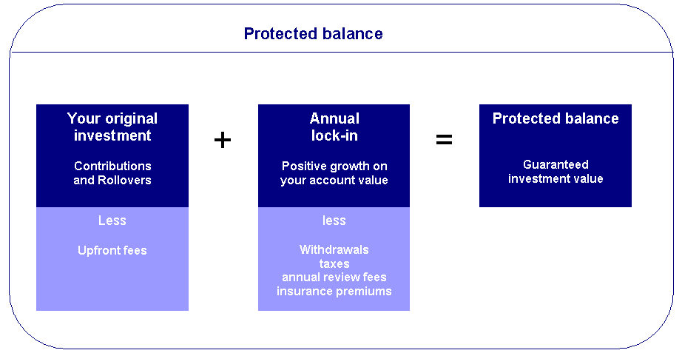

Can I make withdrawals?
Yes, however as discussed earlier in this plan, this is subject to Government legislation.
Certain withdrawals may impact the value of your protected balance. Each dollar withdrawn up to 15% of your available balance, or when your account value is greater than your protected balance, will reduce your protected balance by the same amount.
If your protected balance is greater than your account value, annual withdrawals in excess of 15% of your available balance will reduce your protected balance by an amount greater than your withdrawal. For further details on how this is calculated please refer to the PDS.
You will be notified before you reach this threshold. At that time we can consider whether you make the withdrawal, defer it or withdraw it from a non-protected investment.

Salary Sacrifice to Superannuation

- Frank is currently Salary Sacrificing $12,000 per annum on top of his employer contribution of $4,761 pa.

Recommendation:

- Frank to increase your level of Salary Sacrifice by an additional $33,000 to $45,000 per annum ($3,750 per month) to the accumulation portion of your Mercer Fund.
- When combined with your employer contribution of $4,761 pa, you will have the maximum allowable contributions going in to super.
- Arrange this with your employer as soon as possible.
- As Frank is contributing the maximum to super, Ilse is to draw an income stream that is sufficient to satisfy living requirements (i.e. $22,000 pa.).
Benefits:

- By salary sacrificing, you are building your superannuation benefits at an increased level, resulting in achieving your retirement capital goals sooner. We estimate your combined super balance will increase by $6,050 per annum.
- The main purpose behind this strategy is to build Frank’s super balance at an increased rate.
- Frank will also receive a reduction in Taxable Income for the contributions that you make.
- Superannuation contributions are concessionally taxed at a maximum of 15% as opposed to marginal tax rates of up to 46.5%.
- Frank’s salary sacrifice contributions will be taxed at a maximum of 15% compared to the 39.5% if taken as income.

Risks:

- All superannuation contributions are considered preserved benefits until a condition of release is satisfied, and only then may your superannuation benefits be accessed.
- Superannuation benefits are subject to market returns and earning rates are not guaranteed.

IMPORTANT: It is important that any salary sacrifice arrangement is clearly documented in writing. You should also confirm with your employer that they are going to continue to pay Superannuation Guarantee Contributions (SGC) on the grossed up amount of your package, i.e. that the SGC will continue to be calculated on the total of your salary + salary sacrificed amount.

Superannuation - Retirement Income Streams

Frank, you currently have a defined benefit fund with a balance of approximately $310,000. You will salary sacrifice into the accumulation portion of this fund until retirement.

Ilse, you have recently retired and now have access to the approximate balance of $340,000 from your defined benefit scheme.

Recommendations:

- Ilse, move $150,000 of your funds to AXA North Growth Guarantee (Growth, 15 year term) to commence a new Reversionary Allocated Pension.
- Draw down the minimum pension amount of $3,000 p.a.
- Ilse, move $160,000 of your funds to CFS Wholesale Pension to commence a new Reversionary Allocated Pension.
- Draw down the minimum pension amount of $19,000 p.a.
- Set up your pension payments to be drawn from your most conservative investment options first, that is cash and then fixed interest, allowing your growth assets to maximise their growth potential in positive markets and minimise the negative growth potential in negative markets.
- Adopt a scheduled rebalance of your investment portfolio to retain your selected asset mix over the longer term.

Benefits:

- Once you commence an income stream, the earnings on your superannuation funds used in the purchase price of the pension become tax free. This remains the case for the life of the pension.
- Your capital will be invested according to your risk profile, within a concessionally taxed environment that will keep your asset base ahead of inflation. This structure is much more beneficial as interest from bank deposits is taxable income and your capital is eroded by inflation.
- The commencement of your Allocated Pension will mean that all future income earned on your superannuation capital will be tax free.
- You can withdraw lump sum amounts.
- You will receive consolidated reporting on performance and taxation.

Risks:

- Benefits are subject to market returns and earning rates are not guaranteed.
- Earnings expectation may not be achieved.

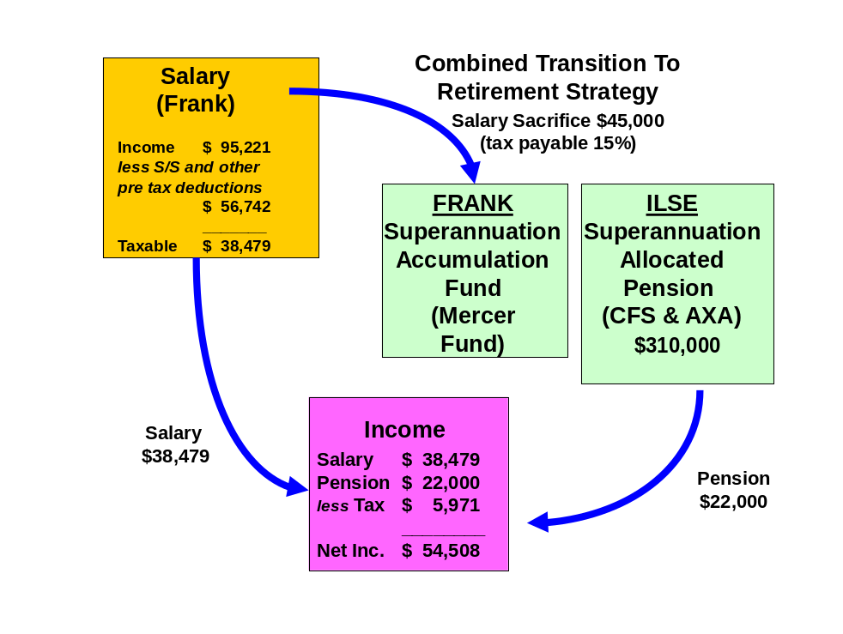

Reversionary Pensions

Recommendations:

Ilse, when you commence your retirement income streams (pensions) you should make them reversionary.

Benefits:
- A reversionary pension enables your tax dependant beneficiary to receive your pension account balance remaining within the superannuation environment. All moneys received by the reversionary beneficiary remain in pension phase and therefore all income earned by the fund or capital gains realised by the fund to pay the benefit pension will not be subject to tax.
- If either the deceased or the recipient of the reversionary pension is over the age of 60, the income stream will not be assessable for income tax purposes.
Risks:

- If the income stream is commuted (either rolled into an accumulation fund or lump sums are withdrawn) within six months after the death of the deceased or 3 months after the grant of probate of that deceased person's will or letters of administration of that deceased person's estate, then it is treated as a death benefit payment. Therefore the moneys would be treated as a lump sum benefit outside of the superannuation environment.
- Death benefits in the form of a pension may only be paid to a “Tax Dependant” which will include the deceased members’ spouse, children under the age of 18 and persons financially dependent on the deceased member (and under the age of 25). In other words if the beneficiary did not fit the above description then they could only receive a lump sum and not a pension, thus they would lose the benefits of being in pension phase.
- If both the deceased member and the tax dependant are aged below 60 years then the pension will be included in the tax dependant’s assessable income less a 15% rebate until the tax dependant turns 60 years at which time the pension will be tax free.

Superannuation Contribution Limits
Table 1- Concessional contribution limits

Concessional contributions include employer and self employed contributions such as salary sacrifice, superannuation guarantee and personal concessional contributions.

Date | Limit (per annum)
Date | Age 35-49 | Age 50 to 64 | Age 65 to 74* | Age75 and over
From 1 July 2009 | $25,000 | $50,000 | $50,000 | Cannot contribute
*Must be employed at least 40 hours during any consecutive 30 day period in the financial year you would like to make the contributions.
Concessional Contributions were previously known as Deductible Contributions (e.g. Salary Sacrifice).

$50,000 $50,000 $50,000 $50,000 $50,000

$25,000 $25,000 $25,000 $25,000 $25,000

1/7/09 1/7/10 1/7/11 1/7/12 1/7/13 1/7/14

Under age 50
Aged 50 to 75
Table 2 - Non-concessional contribution limits
Date | Limit on after-tax contributions | Eligibility Requirements
Date | Limit on after-tax contributions | Under age 65 | Age 65 to 74 | Age 75 and over
From  1 July 2007 | $150,000 p.a. | May bring forward two years of contributions to make a $450,000 contribution in one financial year | Must be employed* | Can not contribute
$150,000 $150,000 $150,000 $150,000 $150,000

1/7/07 1/7/08 1/7/09 1/7/10 1/7/11 1/7/12

If over age 65 then must be employed
$450,000 over rolling 3 year period

Estate Planning

Although considerable emphasis is placed on wealth creation and protection, a third vital aspect of your financial strategy is the control of the manner in which your wealth will be distributed after your death.

You currently have Wills that include Testamentary Trusts that Lakeside Legal have reviewed and deemed appropriate for your current circumstances.

Recommendation:

We recommend you retain your current Will incorporating testamentary trust provisions and adopt an ongoing review strategy every three years (or earlier if your circumstances change).

Powers of Attorney

You have advised us you do not have Powers of Attorney.

Recommendation:

- We recommend you consult an approved legal practitioner. We have an arrangement with Lakeside Legal Pty who will be able to assist you with this.
- Accordingly we recommend you consult Lakeside Legal Pty Ltd to ensure they are prepared as soon as possible.

There are three ‘standard’ types of Power of Attorney:

- A general Power of Attorney which can provide the donee with restricted or unrestricted authority over the donor’s financial affairs (but not their health care). Such a policy lapses if the donor loses mental capacity.
- An enduring Power of Attorney which provides the donee with authority over the donor’s financial affairs (but not their health care) until they die (i.e. it extends beyond any loss of mental capacity).
- An enduring medical Power of Attorney which provides the donee with authority over the medical needs of the donor if the donor himself is unable to make such decisions (whether temporarily or permanently).
Note 1 - A Power of Attorney may only be granted by someone who is over the age of 18 and who is of sound mind at the time of the grant and capable of fully understanding the nature and purpose of the document they are signing.
Note 2 - The attorney is not able to do anything illegal while operating under a Power of Attorney, nor is he/she able to sign a Will on behalf of the donor, or to transfer the Power of Attorney to someone else unless authorised to do so.

Comment:

Lakeside Legal Pty Ltd was formed towards the end of 2005 to provide a discrete range of legal services designed to complement and enhance the services and value offered by Lakeside Consultants Pty Ltd to its clients.
The directors of Lakeside Legal are Suzanne Jones who is the lawyer operating the legal business, and Ross Hennig, who is the managing director of Lakeside Consultants.

Investment Recommendations

After considering your investment profile, your financial objectives, the current economy and economic trends, we recommend that your funds be invested in the following manner.

Current Portfolio
ASSETS
Lifestyle Assets | Value
Frank and Ilse
Residential Home | $550,000
Motor Vehicles | $40,000
Total Lifestyle Assets | $590,000

Investment Assets
Frank and Ilse
Shares (QBE) | $20,000
Cash at Bank | $80,000
Total Investment Assets | $100,000

Superannuation Assets
Frank
Mercer Super Trust | $310,000
Ilse
ESSSuper | $340,000
Total Superannuation Assets | $650,000

Total ASSETS | $1,340,000

LIABILITIES
Personal Loans
Frank and Ilse
Residential Home | $40,000
Total Personal Loans | $40,000

Investment Loans
Frank and Ilse
Shares | $100,000
Total Investment Loans | $100,000

Total LIABILITIES | $140,000

NET WORTH | $1,200,000

Notes: As the above information has been used in preparing our recommendations please advise us of any errors or omissions.

Proposed Portfolio
ASSETS
Lifestyle Assets | Value
Frank and Ilse
Residential Home | $550,000
Motor Vehicles | $40,000
Total Lifestyle Assets | $590,000

Investment Assets
Frank and Ilse
Shares (QBE) | $20,000
Cash at Bank (Joint) | $80,000
Cash at Bank (Ilse) | $30,000
Total Investment Assets | $130,000

Superannuation Assets
Frank
Mercer Super Trust | $310,000
Ilse
Colonial First State Wholesale Pension
BT Wholesale Core Australian Share | $22,400
Schroder Wholesale Australian Equity | $19,520
Acadian Wholesale Australian Equity | $14,080
BT Wholesale Core Global Share | $14,080
AXA Wholesale Global Equity - Value | $8,000
MFS Global Equity | $12,000
Platinum Wholesale International | $5,920
CFS Wholesale Property Securities | $5,600
RREEF Wholesale Property Securities | $5,600
CFS WS Colliers Global Property Securities | $4,800
CFC Wholesale Fixed Interest | $40,000
CFS Wholesale Cash | $8,000
Subtotal | $160,000
AXA North Growth Guarantee (Pension)
Vanguard Australian shares high yield fund | $37,500
Vanguard Australian shares index fund | $37,500
Vanguard International Shares Index fund | $23,250
Vanguard International Shares Index fund (Hedged) | $23,250
Barclays property securities index fund | $15,000
Credit Suisse Passive Enhanced Australian Fixed Interest Fund | $9,000
Vanguard International Fixed Interest index (Hedged) | $9,000
UBS cash fund | $3,000
Subtotal | $150,000
Total Superannuation Assets | $620,000

Total ASSETS | $1,340,000

LIABILITIES
Personal Loans
Frank and Ilse
Residential Home | $40,000
Total Personal Loans | $40,000

Investment Loans
Frank and Ilse
Shares | $100,000
Total Investment Loans | $100,000

Total LIABILITIES | $140,000

NET WORTH | $1,200,000

Projected Portfolio Profile Compared to Benchmark

Asset Class | Projected Portfolio | Benchmark Profile for Growth | Deviation
Australian Shares | 19% | 45% | -26%
International Shares | 12% | 31% | -19%
Property | 5% | 10% | -5%
Fixed Interest | 8% | 12% | -4%
Cash | 57% | 2% | 55%
Other | 0% | 0% | 0%

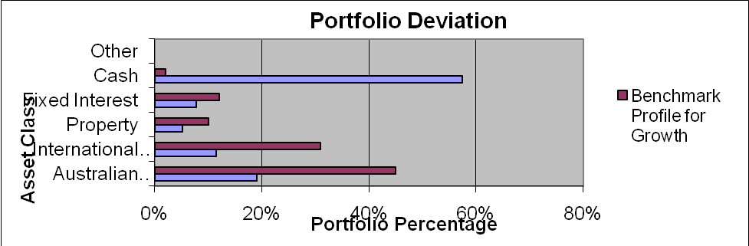

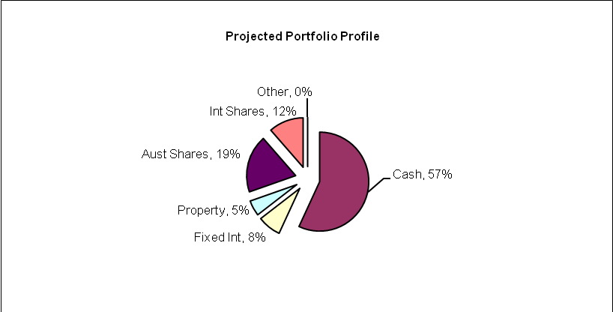

As an industry standard, a variance of 10% within a particular asset class is allowed to cater for individual circumstances, economic events and fund manager asset allocation decisions. Variations outside of this range may be appropriate in certain circumstances.

Note: Your portfolio is overweight in cash and underweight in Australian shares. This is primarily due to the fact that Frank’s defined benefit fund is classed as ‘cash’ for asset allocation purposes. Furthermore, you are currently holding $80,000 in cash which will be used to invest in Australian shares in the short to medium term and you are also holding cash reserves to assist with your renovation.

Colonial FirstChoice Wholesale Investments
The FirstChoice Wholesale Investments is a multi-manager investment solution which combines wide investment choice with a competitive and simple fee structure, backed up by a high standard of service support from Colonial First State.

The minimum initial investment the Colonial FirstChoice Wholesale Investments Plan accepts is $100,000. There is no minimum additional investment amount required, however minimum regular investment and withdrawals are set at $500. Regular payments can also be made by BPay. You can then monitor and manage your investments over the Internet, by phone or through your financial adviser.

Reasons and Benefits
The major features of the Colonial FirstChoice Wholesale Investments are as follows:

Sector Specific Diversification
A strong range of investment options with access to more than one specialist manager within each asset class. This approach captures the competitive advantages of each manager. We anticipate this will provide higher returns than can be obtained from using diversified funds with, say, only one fund manager.

Simplicity
Consolidated reporting from Colonial First State.

Ease of Management
Automatic investment re-balancing and switching to help you easily and conveniently keep your investment strategies on track.
- We recommend that annual automatic rebalancing is elected.

Highly competitive and simple to understand fee structure
- No entry fee applies to this investment however, with your agreement; your Financial Adviser may wish to charge a one off fee to cover upfront costs.
- An ongoing management fee ranging from 0.31% p.a. to 2.96% p.a. applies, depending on investment options chosen. This fee is all inclusive, covering Colonial First State's administration fee and investment management fee. No ongoing remuneration is paid to Guardian Financial Planning out of this fee.
- The weighted average management fee for the Colonial FirstChoice Wholesale Investments Plan is 1.11% for Growth, 1.37 for High Growth and 1.2% for Gearing.
- You can agree with your Financial Adviser to have an ongoing Adviser Service Fee for advice paid directly from your investment. The ongoing fee will be deducted monthly from your investment options.
  - Our normal 0.75% p.a. Adviser Service fee will apply.
- No switching fees or exit fees apply to this investment.
- Within the Wholesale Investment plan a buy-sell spread of between 0 – 0.55% applies depending on investment option. Please refer to the Product Disclosure Statement for details.
Your Balanced Portfolio
Your investment objective is to achieve capital growth over the long term. Growth investors seek growth on capital with little demand placed on income from the investment portfolio. Generally growth investors can tolerate a high level of capital volatility, in anticipation of higher returns over the longer term. Such a portfolio is suitable for investors with a minimum investment timeframe of at least 5 years.
- The defensive component of the growth portfolio was constructed to lower the risk of the overall portfolio by providing some diversification of asset classes. The funds that were chosen were those that exhibited lower correlations to equities and low overall volatility.
- The CFS FirstChoice Fixed Interest Fund is a multi-manager fund investing in a range of sub-managers. The fund has exposure to a range of passive and active Australian and international fixed interest strategies that invest across a variety of the sub-sectors of fixed interest including Australian and international government bonds, Australian hybrid securities, structured credit and emerging market debt.
- The CFS Colliers Global Property Securities Fund was chosen to give exposure to listed property markets globally. The CFS Colliers Global Property Securities Fund is a relatively diversified portfolio in terms of stock numbers and geographic exposure. The different pattern of returns provided by a global portfolio of property securities can enhance returns for an Australian investor’s portfolio while reducing volatility, essentially by spreading investment risk.
- The CFS Property Securities Fund and the RREEF Property Securities Fund invest into the Australian listed property trusts (LPT) sector. Both funds offer a diversified exposure to the Australian LPT market and should provide a relatively high yield.
- The Australian equity managers have been selected because they complement each other and provide diversification through market cycles. All managers chosen are active managers who are expected to add value above the benchmark over the appropriate time horizon. The Acadian Australian Equity Fund is managed by Acadian Asset Management. Acadian is a quantitative ‘value’ style manager and will tend to perform more strongly in falling equities markets. The Schroder Australian Equity Fund is managed by Schroder Investment Management. Schroder is a ‘growth’ style manager that will tend to perform more strongly in upwards equities markets. The BT Core Australian Share Fund is managed by BT Investment Management. BT is a style neutral manager which will tend to perform fairly well across most market conditions.
- The international equity managers have been selected because they complement each other and provide diversification through market cycles. All managers chosen are active managers which are expected to add value over time. Note that, because these managers are very active, they can go through short to medium term periods of underperforming the wider market. The AXA Global Equity Growth is a ‘growth’ style fund managed by Alliance Capital that will focus on identifying companies with the potential to provide strong capital growth. The BT Wholesale International Shares Trust is managed by AQR Capital Management. AQR is a ‘style neutral’ quantitative manager which will tend to perform well across a range of market conditions. The AXA Global Equity Value Fund is a ‘value’ style fund managed by Bernstein Investment Management and will tend to perform more strongly in falling equities markets. The Platinum International Fund is a ‘value’ style manager that is considered to have an absolute return focus. The fund manager will tend to perform significantly different from the benchmark due to the flexibility and absolute return focus of the fund.

Replacement of an Existing Product

Type of Fee or Cost | Current – ESS Super – Balanced Portfolio | AXA North Growth Guarantee – Growth Portfolio | Colonial Wholesale Super Fund – Balanced Portfolio
Contribution/Entry fee – this is the fee for initial and subsequent contributions. | Nil | Nil | Nil
Withdrawal/Exit Fee – this is the fee for each withdrawal you make | Nil | Nil | Nil
Switching Fee – fee charged for switching between investment options in the super fund. | Nil | Nil | Nil
Protection Fee | Not Available | 1.85% | Not Available
Administration Costs – are the fees and costs that cover the operation of the fund. They include admin, member and other fees charged by the product issuer | 0.35% | 0.81% | Nil
Adviser Service Fee – additional fee paid to financial adviser | Nil | 0.55% | 0.75%
Investment Costs - Current – are the fees and costs the product issuer charge for investing the assets. These include fees paid to external fund mgrs. | 0.54% | 0.35% | 1.00%
Annual average cost - Total $310,000 investment | $2,759 | $11,036 | $5,425
Annual average cost – Recommended portfolio; $150,000 AXA, $160,000 CFS. | - | $5,340 | $2,800

The investment cost will vary depending on which fund you are invested in, the assets it invests into and how actively they manage their portfolios, amongst other things. Typically these costs should not be compared directly.

Outcomes Post Recommendation:

- You will gain access to a diversified portfolio of funds that matches your investor risk profile and investment objectives.
- You have ‘protected’ $150,000 of your funds and maintained exposure to a diverse growth portfolio.
- Note that the increase in investment costs is due to the protection fee and the provision of access to a diversified portfolio of funds.

The investments we have selected for you mean that you are better diversified and your asset allocation is more in line with your investor risk profile. On our analysis this should position you for better long term returns.

Cash Flow Projections Post Recommendation

Following the implementation of the strategy and investment recommendations within this report, we estimate that your future tax liabilities and cash flow to be as follows.

Estimated Tax Liability for Frank

Income Source |  | Amount Received | Deduction | Taxable Income | Tax
Gross Salary |  | $95,221
Deductions
Employer Super Contributions |  |  | $4,761
Other |  |  | $840
Salary Sacrifice |  |  | $45,000
Motor Vehicle Salary Sacrifice |  |  | $6,141
TAXABLE INCOME |  |  |  | $38,479
TAX PAYABLE |  |  |  |  | $5,394
Medicare Levy |  |  |  |  | $577
NET TAX |  |  |  |  | $5,971

Current Estimated Cash Flow

Based on your incomes and expenses of your proposed portfolio, we estimate your cash flow over one whole financial year to be as follows.

 | Frank | Ilse | Total
Income
Salary | $95,221 | $0 | $95,221
Income Received | $0 | $22,000 | $22,000
Sub Total | $95,221 | $22,000 | $117,221
Less Income Tax | $5,971 | $0 | $5,971
Less salary sacrifice | $45,000 | $0 | $45,000
Less other pre-tax deductions | $11,742 | $0 | $11,742
Net Income | $32,508 | $22,000 | $54,508
Less Budgeted Expenditure | $27,000 | $27,000 | $54,000
Income Surplus | $5,508 | ($5,000) | $508

What is paid to your adviser

Plan Fee

You have agreed to a Plan Fee of $2,200 (inclusive of GST), which will be deducted from your superannuation fund.

Internal Investment Fees

Colonial FirstChoice Management Fee
Colonial FirstChoice charges a Management Expense Ratio to cover their administration costs and the associated costs of managing your funds and the advisers trail fee. Based on your current portfolio value, we have provided an estimation of the costs you will pay.

Colonial FirstState FirstChoice Investments | MER  % | Amount invested   $ | Estimated  fee  $
BT Wholesale Core Australian Share | 1.00% | $22,400 | $224
Schroder Wholesale Australian Equity | 1.00% | $19,520 | $195
Acadian Wholesale Australian Equity | 1.21% | $14,080 | $170
BT Wholesale Core Global Share | 1.31% | $14,080 | $184
AXA Wholesale Global Equity - Value | 1.26% | $8,000 | $101
MFS Global Equity | 1.21% | $12,000 | $145
Platinum Wholesale International | 1.81% | $5,920 | $107
CFS Wholesale Property Securities | 0.81% | $5,600 | $45
RREEF Wholesale Property Securities | 0.81% | $5,600 | $45
CFS WS Colliers Global Property Securities | 1.00% | $4,800 | $48
CFC Wholesale Fixed Interest | 0.75% | $40,000 | $300
CFS Wholesale Cash | 0.41% | $8,000 | $33
Total Ongoing Fees | 1.00% | $160,000 | $1,599

 Colonial FirstChoice’s Management Fee is calculated on the value of your total portfolio. As such we have used you current portfolio to estimate your annual ongoing fee.

Additional details of the above fees are outlined in Colonial’s Product Disclosure Statement

AXA North Management Fee
Axa charges a Management Expense Ratio to cover their administration costs and the associated costs of managing your funds and protecting the capital. Axa’s Management Fee is calculated on the value of your total portfolio. Based on your current portfolio value, we have provided an estimation of the costs you will pay.

AXA North Superannuation Plan | Management Expense Ratio  % | Amount invested  $ | Estimated  fee  $
Australian Equity
Vanguard Australian shares high yield fund | 0.40 | $33,750 | $135.00
Vanguard Australian shares index fund | 0.34 | $33,750 | $114.75
International Equity
Vanguard International Shares Index fund | 0.36 | $33,750 | $83.70
Vanguard International Shares Index fund (Hedged) | 0.36 | $33,750 | $83.70
Property
Barclays property securities index fund | 0.31 | $15,000 | $46.50
Fixed Interest
Credit Suisse Passive Enhanced Australian Fixed Interest Fund | 0.25 | $9,000 | $22.50
Vanguard International Fixed Interest index (Hedged) | 0.31 | $9,000 | $27.90
Cash
UBS cash fund | 0.22 | $3,000 | $6.60
Total ongoing fees | 0.35 | $150,000 | $520.65

Additional details of the above fees are outlined in the AXA’s Product Disclosure Statement.

Your account will incur a Protection fee of 1.85% as part of the guarantee feature.

Upfront and Ongoing Fee Disclosure

The following is provided to assist you to gain a clear understanding of the payments and benefits that Guardianfp Limited, our associates and I will be entitled to receive for services provided to you, if you adopt the recommendations in this plan.

There is an entry fee payable of which the break-up of the fee is disclosed as follows:

 |  |  | Total Fee Paid by Client |  | Total Commission Payable to Financial Service Licensee/Financial Adviser and /or its Associates
Investment Details |  | Amount Invested | (%) ($) |  | Initial  (%) ($) |  | Ongoing  (%) ($)
Colonial FC Wholesale Pension |  | $160,000 | Flat Fee | $2,200 | 0.0 | $0 | 0.75 | $1,200
AXA North Guaranteed |  | $150,000 | Flat Fee | $0 | 0.0 | $0 | 0.55 | $825
Total |  | $310,000 |  | $2,200 |  | $0 |  | $2,025

My associates and I will receive 100% of the commission disclosed above, as a flat annual fee is paid to Guardianfp Limited.

Ongoing commission is generally paid until the investment is redeemed. The actual amount will vary over time according to the mix of the underlying investments and the total value of your funds under management.

For Colonial Wholesale Super - Ongoing Commission is an additional adviser service fee paid by you from your fund balance.

Disclosure Statement

To help you understand the full benefits, details and risks of our recommended products, please read the Product Disclosure Statements that we will provide you.

Please let us know if you have any questions.

Cooling-off periods

After investing in a financial product, you have a “cooling-off” period in which to change your mind if you don’t think the product meets your needs. The cooling-off period usually starts when you’re told the product has been set up. The length of the period varies with each product.

Each Product Disclosure Statement explains your cooling-off rights.

If you wish to cancel a product, please tell us in writing so we can contact the product issuer within the time restrictions.

No guarantee

The investments we recommend for you must be appropriate for you. However, we don’t guarantee they’re the best available or that they’ll perform in a particular way. Product performance depends on the features and risks described in the Product Disclosure Statements given to you.

Please take the time to read the PDS and understand the products we have recommended. If you have any questions, please contact us.

Tax

There may be tax implications if you act on this advice. We recommend you ask a tax professional to assess the impact on your short and long-term financial positions.

Are My Product Recommendations Restricted?

Non Superannuation Products

Yes, when making non superannuation product recommendations I can only choose products from our Approved Product List (APL). This list is compiled by a dedicated Investment Committee, made up of Research Manager, Directors and Representatives who carefully analyse investment products, prior to including any product on the APL. The Committee utilises leading industry research houses to assist with their analysis.

The APL is regularly reviewed to ensure that all funds, managers and investment companies continue to meet our ongoing stringent requirements.

Superannuation Products

Yes, when making superannuation product recommendations I can only choose products from our Approved Product List (APL). However, if you have a superannuation product that is not on our APL, I am still able to make recommendations in relation to that fund providing I have conducted the necessary research and have a thorough knowledge of the fund.
.
Insurance Products

I can recommend policies from a list of insurance companies and their products that are currently researched by Rice Walker Research.

What is My Responsibility to You?

I am responsible for providing you a ‘clear, concise & an effective’ method of communicating my recommendations to you. The recommendations are based on your goals and objectives, personal and financial situations, and other information collected from you. The recommendations are appropriate for your needs and current situation.

As the SoA is specifically prepared for you and based on your situation, I do not take any responsibility for any third party persons acting on all or on a part of any advice or recommendations made in this SoA.

Do I Guarantee the Investments I have recommended?

No. By law, the investments I have recommended must be appropriate to you, however, I do not guarantee that the recommended investments are the best for you or that they will perform in a certain way.

I have included financial projections (please refer to the Appendix) to illustrate key aspects of my advice to you, however, they are assumptions and estimations only, and they are not guaranteed to occur over the timeframe of the SoA-contained projections.

Is Your Personal Information Protected?

We may be required from time to time, to disclose information about you to representatives of Guardian Financial Planning, and other companies within the Promina Group and to other professionals, insurance providers, superannuation trustees, regulators and product issuers in order to provide our services and arrange for the issue of Financial Products.

Please ensure you have read the ‘How we handle your Personal Information’ section of the Financial Services Guide (FSG) for more information.

Summary

Plan Implementation

Frank and Ilse, you have taken another next step to reach your personal and financial goals and objectives. The most important stage of the process is to put the plan into action. There are a number of steps required for the implementation of this plan:

Action | Anticipated Start Date | Estimated Completion Date | Responsibility
Detailed review of the recommendations | 3 September 2009 | 10 September 2009 | Frank, Ilse
Authority to Proceed returned with any amendments | - | 13 September 2009 | Frank, Ilse
Applications returned | - | 13 September 2009 | Frank, Ilse
New Super Fund Application Process | 13 September 2009 | 27 September 2009 | Nick Quinn
Pension Application Process | 27 September 2009 | 27 October 2009 | Nick Quinn
Salary Sacrifice arrangement |  | 27 September 2009 | Frank
Confirmation of all in place | - | 2 November 2009 | Andrew Lord
Book Post-Implementation / Review Appointment | - | May 2010 | Frank, Ilse, Andrew Lord

Your Financial Plan

In preparing this plan we have taken into account your specific goals and objectives, and have designed an appropriate strategy that aims to accomplish these.

It is important to appreciate that we live in an ever changing world. Accordingly, it is probable that, overtime, the basis of our calculations (inflation rates, investment rates etc) will change, as will your own requirements and expectations. It is therefore recommended you review your plan on a regular basis to ensure you are still on track to achieve investment objectives.

It is essential to have your investment portfolio reviewed to ensure that the investments are working to their maximum potential and any changes to the investment markets, taxation etc. are promptly and correctly responded to.

Next steps

How to get started

To implement our recommendations in this plan, please do the following:

- Make sure you read this Statement of Advice and Product Disclosure Statements
- Contact us if you have any questions
- Tell us immediately if any information is incorrect
- Complete the application forms in the Product Disclosure Statements
- Sign and date the Authority to Proceed
- Return the forms to us
- Retain a copy for your records

Finally

Please note, as with any investments, their future value may fluctuate, particular rates of return cannot be guaranteed and you may not get back what you originally invested. We have provided a brief summary of the managed investment products recommended, however, you will need to study the investment statements of the recommended products carefully before you decide to invest.

Appendix – Assumptions

In preparing your financial strategy, it is necessary to make certain assumptions. These are outlined below.

- Current superannuation rules, taxation legislation and social security rates have been used;
- Asset allocations for your risk profile are based on directions from Guardian FP in conjunction with research from research house van Eyk;
- Life expectancies from the Australian Life Table 2000/02 have been used where relevant;
- Where applicable Medicare Levy of 1.5% is included on marginal tax rates;
- Throughout this plan, an inflation rate of 3% per annum has been used, and a default rate of return of 7% on share and managed fund investments. Projections are calculated in today’s dollars;
- Superannuation contributions tax of 15% is taken into consideration where relevant;
- There is no tax on the earnings within pension products.
- No consideration has been made for Eligible Termination Payments, foreign sourced income or capital gains or losses, unless stated otherwise;
- 100% franking is assumed on all Australian share distributions at a rate of 70%. An expected dividend yield of 3.5% is used in all income calculations;
- Where estimated tax liability has been calculated involving managed funds, an assessable capital gain of 5% of the portfolio value has been assumed.
- Cash flow projections are based on estimated income of your investment portfolio and any other income such as salary. Estimated expenses and tax are also included;

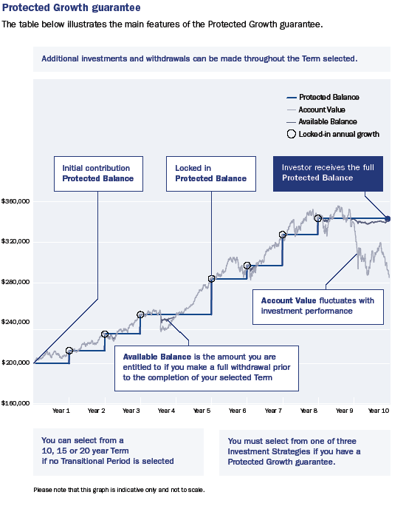
North Protected Growth guarantee

North’s Protected Growth option guarantees to:
- lock in any growth as a result of positive investment performance on your Account Value provided your Account Value is greater than your current Protected Balance on the Guarantee anniversary date; and
- return, by the end of the Term, any contributions (net of Upfront fees) made into your account.

The guaranteed amount is known as your Protected Balance. The total amount you are entitled to receive from North at the end of your Term will at least be equal to your Protected Balance.

The ‘dynamic hedging’ difference

North is the only product in the current Australian market that can protect investors’ wealth without impacting how that wealth is invested through a unique risk management technique – dynamic hedging. Unlike most other risk management techniques available in Australia, we don’t rebalance North investors away from growth assets into cash or fixed-interest assets following market downturns or interest rate falls. Instead, our unique dynamic hedging method allows investors to remain fully invested in their chosen asset, with the liability of the guarantee resting with AXA.

Flexibility

North provides investors with all the flexibility of a standard platform including:

- ability to invest in over 45 managed funds∙
- switch between investment options∙
- transition back and forth between superannuation and pension, and∙
- make regular contributions and withdrawals (including pension payments).∙
Investment Strategy

North provides access to four investment strategies:

Investment Strategy | International Equity  allocation  up to | Australian  Equity  allocation  up to | Property allocation  up to | Fixed  Interest^ | Cash  allocation  up to
Investment Strategy 1 | 26% | 35% | 10%
Investment Strategy 2 | 32% | 45% | 10% | Unlimited | Unlimited
Investment Strategy 3 | 50% | 50% | 30%

^ Fixed interest includes Australian Fixed Interest and International Fixed Interest. AXA reserves the right to review the Investment Strategy limits annually. You will be notified of any changes in advance.

Protected Growth guarantee Guarantee Fee Table

10 year Term Strategy 1 Strategy 2 Strategy 3
Nil Transitional Period | 1.35% pa | 2.40% pa | 2.95% pa
1 year minimum Transitional Period | 1.20% pa | 1.95% pa | 2.60% pa
5 year minimum Transitional Period | 1.05% pa | 1.60% pa | 1.95% pa
15 year Term Strategy 1 Strategy 2 Strategy 3
Nil Transitional Period | 1.20% pa | 1.85% pa | 2.25% pa
20 year Term Strategy 1 Strategy 2 Strategy 3
Nil Transitional Period | 1.00% pa | 1.55% pa | 1.85% pa
1 year minimum Transitional Period | 0.95% pa | 1.45% pa | 1.75% pa
5 year minimum Transitional Period | 0.90% pa | 1.35% pa | 1.55% pa

North administration fee
Total Account Value | No trail commissions % pa | With full trail commission % pa
$0 to $149,999 | 0.95 | 1.46
$150,000 to $249,999 | 0.85 | 1.36
$250,000 to $399,999 | 0.65 | 1.16
$400,000 to $749,999 | 0.60 | 1.11
$750,000 to $999,999 | 0.55 | 1.06
$1 million plus | 0.50 | 1.01

Full trail commission is 0.55 per cent per annum and is negotiable with your financial adviser. After RITC the full trail commission charged to your account is up to 0.51 per cent per annum.

Important informationThis publication has been prepared to provide you with factual information only. It is not intended to take the place of professional advice and you should not take action on specific issues in reliance on this information. In preparing this information, we did not take into account the financial objectives, situation or particular needs of any particular person. Before making a decision whether to acquire this product, you need to consider (with or without the assistance of an adviser) whether this information and the information contained in the Product Disclosure Statement (PDS) is appropriate to your needs, objectives and circumstances. Copies of the PDS can be obtained from your adviser or by calling 1800 655 655. Applications for AXA Australia products will only be accepted on receipt of an application form accompanying a current PDS. The National Mutual Life Association of Australasia Limited (NMLA) and its associates derive income from issuing this product, full details of which are contained in the PDS. This information is provided for persons in Australia only and is not provided for the use of any person who is in any other country.

Authority to Proceed

I Frank Thompson and I Ilse Thompson of
78 Brady Road
Gisborne VIC 3437

State that:

We have read and understood the Financial Plan presented to us by Andrew Lord B Bus (Acc), Dip FS (Fin Plan) from Guardianfp Ltd trading as Guardian Financial Planning, and authorise him to proceed with the recommendations as outlined below:

Investment | Amount
Ilse - Colonial FirstChoice Wholesale Pension | $160,000
Ilse – AXA North Growth Guarantee (Pension) | $150,000

All fees and charges have been explained to me/us.

We authorise Andrew Lord B Bus (Acc), Dip FS (Fin Plan) to act in his capacity as our Financial Adviser regarding these investments and to act on my instructions provided by (tick whichever is applicable):

- Facsimile

- Email

- Writing

We acknowledge that:

- We have received and read a Financial Services Guide.
- We have provided all information to the best of my knowledge for the preparation of this Statement of Advice.
- Our adviser is not a taxation adviser, and estimates of tax positions are estimates only.
We should seek advice from a registered tax agent for taxation advice.

q We accept the recommendations made in this Report and give authority to Guardianfp Ltd
ABN 40 003 677 334 to proceed with the implementation of those recommendations.

Modifications to recommendations requested by client

Signed: | _________________________________ | ____/______/______
 | Frank Thompson | Date
Signed: | _________________________________ | ____/______/______
 | Ilse Thompson | Date
Signed: | _________________________________ | ____/______/______
 | Andrew Lord  B Bus (Acc), Dip FS (Fin Plan) | Date

